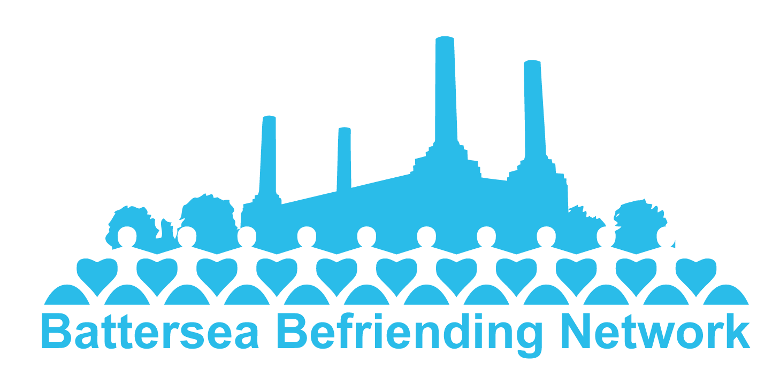

***Building hope and confidence together***

# Battersea Befriending Network (BBN)

# Code of Conduct for Volunteers

## Principles

BBN appreciates and values the volunteers in BBN who give generously of their time, expertise and skill, with enthusiasm and goodwill. This code of conduct sets out BBN’s expectations of volunteers and should be read alongside the Volunteer Policy.

As an adult volunteering for BBN you have a responsibility to ensure that everyone using BBN’s services is protected from harm. It is the responsibility of each volunteer in BBN to ensure that:

* their behaviour is appropriate at all times;
* they observe the rules established for the safety and security of adults at risk;
* they follow the procedures regarding any suspicion, disclosure or allegation of abuse;
* they recognise the position of trust in which they have been placed; and
* in every respect, the relationships they form with the vulnerable adults are appropriate

All persons volunteering for BBN must accept and understand this code of conduct.

# Code of conduct

**BBN expects that you will**:

* Fulfil your role as outlined in the role description
* Follow BBN’s policies and procedures and act in a way that is in line with the purpose and values of BBN
* Act honestly, responsibly and fairly
* Treat everyone with fairness, equality, dignity and respect
* Oppose and avoid all forms of unlawful discrimination
* Respect the right to personal privacy of a vulnerable adult
* Avoid unacceptable situations within a relationship of trust, *e.g.* an exploitative relationship with a vulnerable adult
* Keep personal information about the befriendee confidential, and stored securely
* Inform befriendees, and BBN, of any changes that affect your role with as much notice as possible
* Use the support available within BBN: as a befriender, your mentor and the Volunteer Support Group; as a mentor, the Mentors group
* Take any allegations or concerns of abuse seriously and as a befriender discuss them with your mentor immediately, and as a mentor, with the safeguarding lead
* Observe safety procedures and report any health and safety concerns
* Disclose any charge, conviction or caution by prosecuting authorities to the safeguarding lead within BBN. For the avoidance of doubt, volunteers are not required to disclose the facts of ‘spent’ convictions under the Criminal Justice (Spent Convictions and Certain Disclosures) Act 2016 (as amended) to BBN.

**BBN expects that you will not**:

* Engage in any activity that may cause physical or mental harm or distress to someone, nor in any inappropriate behaviour or contact, whether physical, verbal or sexual
* Form a relationship with a vulnerable adult that is an abuse of trust
* Unlawfully discriminate because of the protected characteristics (Equality Act 2010) of age, disability, gender reassignment, marriage and civil partnership, pregnancy and maternity, race (including colour, nationality and ethnic or national origin), religion or belief, sex and sexual orientation
* Connect with, or make any reference to, befriendees on social media
* Seek any payment, reward or benefits in the course of your role, although this does not exclude exchange of small gifts for special occasions, and hospitality within the norms of a friendship.
* Seek to unduly influence the befriendee
* Be affected by alcohol, drugs or medication which will impair your ability to carry out your role while volunteering
* Engage in illegal activity while carrying out your role
* Improperly disclose, during or after your involvement with BBN, confidential information gained in the course of the role.
* Bring BBN into disrepute

If a volunteer is found to be in breach of the standards outlined in this Code of Conduct or any of BBN’s other policies and procedures, this may result in the volunteer’s position being ended. Volunteers acknowledge that no employment relationship is created in the context of their role with BBN.

The Trustees will review the Code of Conduct for Volunteers every 3 years or as appropriate.

Date approved April 28th 2021